Strategic Goals & Short-term Institutional Objectives 2009-2010
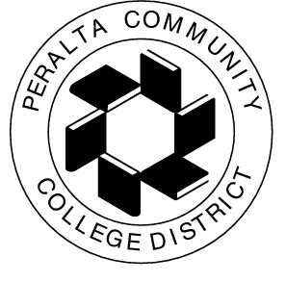

The following are the Peralta Community College District’s short-term objectives set by the Strategic Management Team for Academic Year ’09-’10 (July 1, 2009 – June 30, 2010), to be evaluated in Summer 2010.

Strategic Focus for 2009-2010: Given the state of the economy and state budget, our focus this year will be to leverage resources through innovation and collaboration to enhance student success.

Strategic Goals | 2009-2010 Annual Institutional Objectives
A: Advance Student Access, Equity, and Success | A.1 Access: Achieve 19,100 funded FTES enrollment while increasing productivity by .5 FTES/FTEF  A.2 Success and Equity: Enhance student success and equity programs.  A.3 Accreditation: Receive a positive response from the accreditation follow-up visit on March 15, 2010.
B: Engage Community and Partners | B.1 Partnerships: Expand community partnerships, for example, grants, contract education, Career Advancement Academy, Logistics, Health Care, Carnegie, CHORI, etc.
C: Build Programs of Distinction | C.1 District-Wide Update of Program Reviews/SLO’s: Complete updated program reviews for instruction and student services with a specific focus on student learning outcomes and assessment.  C.2 Resource Master Plans: Complete master plans for Facilities, Fiscal, Human Resources, Information Technology, and Marketing.
D: Create a Culture Innovation and Collaboration | D.1 District-Wide Collaboration: Implement the first-year pilot test of the Planning-Budgeting Integration Model; evaluate effectiveness; and develop a follow-up plan to implement lessons learned in 2010-2011.
E: Develop Resources to Advance and Sustain Our Mission | E.1 Alternative Resources: Increase alternative funding by 30% over 08-09 through contract education, fundraising, international and out-of-state enrollments, and grants, etc.  E.2 Fiscal Stability: Maintain fiscal stability during the state budget crisis and funding reductions.

