PERALTA COMMUNITY COLLEGE DISTRICT
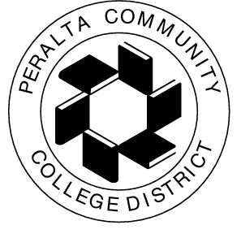

Office of Educational Services

Date: May 28, 2015

To: Katherine Maeve Bergman, Dean, BCC
Peter Crabtree, Dean, Laney College
Char Perlas, Dean, College of Alameda
Ahmad Mansur, Dean, Merritt College

From: Karen Engel, Director of Economic & Workforce Development

CC: Carmen Fairley, Coordinator of Grants and Special Programs
Tom Wong, Internal Auditor
Mike Orkin, Vice Chancellor, Educational Services
Peralta District-wide CTE Committee

Re: Mandatory training re Time & Effort Certification processes

Please mark your calendars for a mandatory training regarding Peralta’s policies and procedures for monitoring and submitting grant-related Time & Effort Certifications

When: June 17, 3-5 p.m.
Where: Peralta District Office Board Room
Who: All CTE Deans and related grant funds managers and support staff

Thank you.

