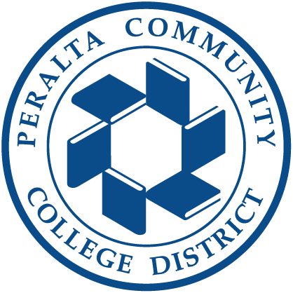
PERALTA COMMUNITY COLLEGE DISTRICT
BOARD OF TRUSTEES
Trustee Area 1
APPOINTMENT APPLICATION
APPLICATION DEADLINE
Monday, October 5, 2026 • 5:00 p.m. Pacific Time

Trustee Area 1 includes the City of Alameda and a portion of Oakland.
The appointee will help govern the entire Peralta Community College District on behalf of its students and communities.

Welcome and Overview
Thank you for considering service on the Peralta Community College District Board of Trustees. The Board invites applications from eligible residents of Trustee Area 1 who are committed to students, public education, responsible stewardship, and thoughtful, collaborative governance.
The Board of Trustees will appoint a new trustee by November 3, 2026, and the new trustee will be seated at the organizational meeting of the Board in December 2026. The newly appointed trustee will maintain the seat for the remainder of the current term through November 2028.
This packet explains the District, the trustee role, eligibility and residency requirements, the appointment process, and the materials required for a complete application. It also includes the application form and eight written questions.
A DISTRICTWIDE GOVERNING RESPONSIBILITY
The appointee will represent Trustee Area 1, which includes the City of Alameda and a portion of Oakland. Like every trustee, the appointee will share responsibility for the success, quality, fiscal health, and long-term stewardship of the entire District.

Peralta Mission, Students, and Communities
The Peralta Community College District is a collaborative of colleges advancing social and economic transformation for students and the community through quality education, rooted in equity, social justice, environmental sustainability, and partnerships.
Peralta was founded in 1964 and includes Berkeley City College, College of Alameda, Laney College, and Merritt College. Together, the colleges serve approximately 20,000 students each year through degrees, certificates, university-transfer preparation, career education, basic-skills and lifelong-learning opportunities, and student support services.
Peralta students bring varied educational goals, identities, ages, work and family responsibilities, life experiences, and pathways into higher education. The Board’s work should remain grounded in student access, equity, learning, completion, belonging, and economic and civic opportunity.
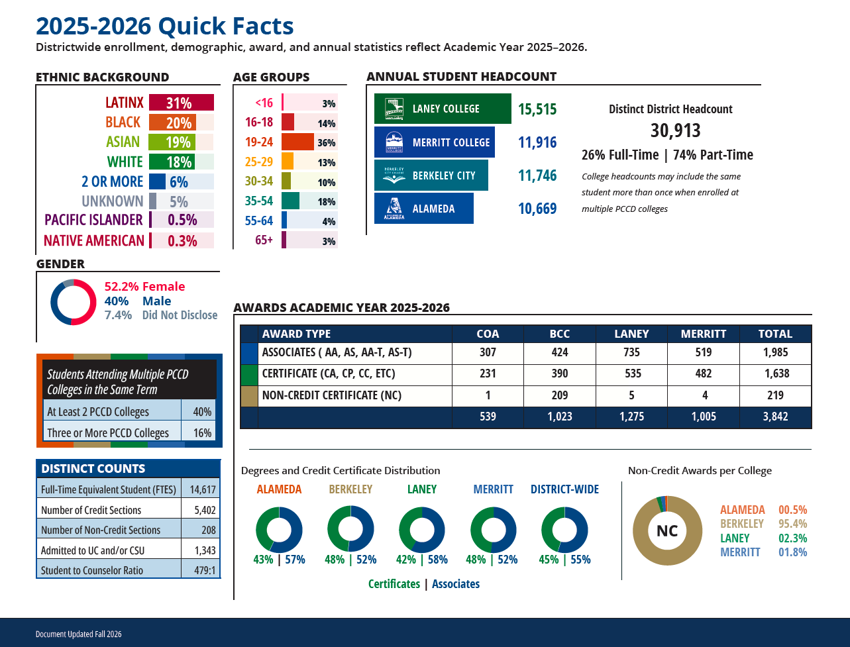

Trustee Area 1
Trustee Area 1 includes the City of Alameda and a portion of Oakland. Applicants must reside within the official Trustee Area 1 boundary and be registered voters.
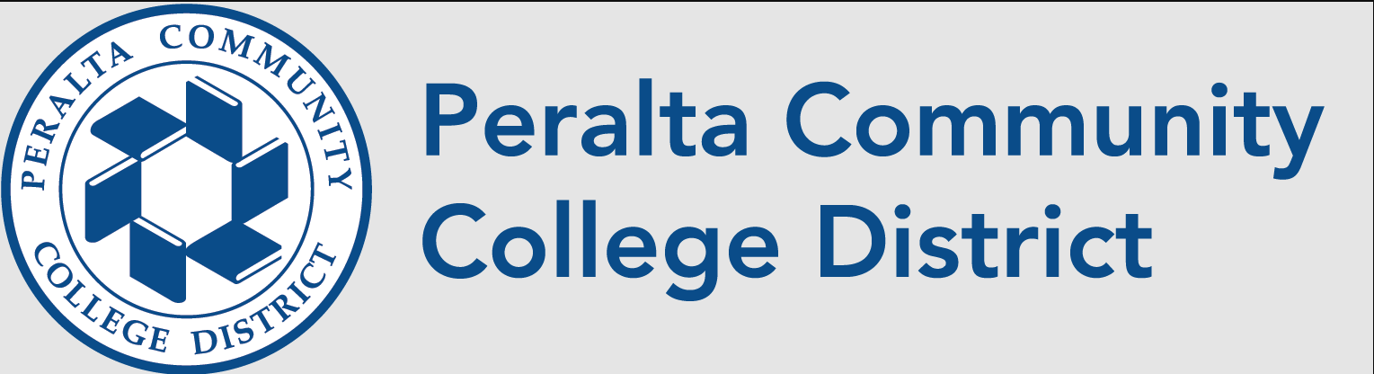
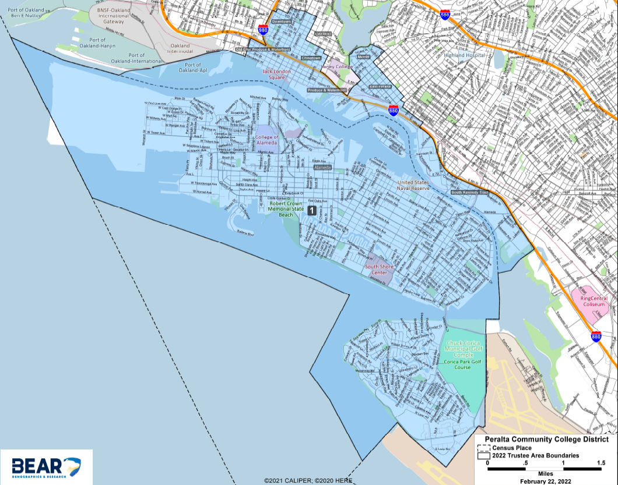
Trustee Area 1 map
RESIDENCY CONFIRMATION REQUIRED
Applicants are responsible for confirming that their residence is located within Trustee Area 1. District staff will verify residency and other eligibility requirements before an application advances for Board consideration.

The Trustee Role
The Board of Trustees is the District’s seven-member elected governing board. Trustees govern on behalf of the public and act collectively as a Board; an individual trustee does not direct employees, administer programs, or exercise the authority of the Board alone.

Core responsibilities
- Represent the public interest and keep student success and equity central to Board decisions.
- Establish policy, mission, strategic direction, and ethical and legal standards.
- Assure fiscal health, institutional stability, educational quality, and accountability.
- Hire, support, and evaluate the Chancellor, and delegate day-to-day management to the Chancellor.
- Monitor institutional performance, ask informed questions, and make decisions using evidence.
- Advocate for the District while maintaining open, accessible, welcoming, and lawful public governance.

Expected commitment and conduct
- Prepare for and attend regular and special Board meetings, including public meetings that may extend into the evening.
- Participate in orientation, trustee education, college visits, and required ethics, open-meeting, and governance training.
- Understand and comply with the Brown Act, conflict-of-interest requirements, Board policies, and confidentiality obligations applicable to lawful closed sessions.
- Listen respectfully to students, employees, labor organizations, community members, and partners while exercising independent judgment.
- Work constructively with fellow trustees and the Chancellor, including after the Board reaches a decision. Be willing to adhere to the Board’s adopted Statement of Cooperation.
- Devote the time needed to review complex educational, fiscal, facilities, personnel, policy, and accreditation matters.

Trustee Compensation, Benefits, and Professional Development
Trustees are currently authorized to receive a monthly stipend of $432.60, subject to meeting-attendance requirements and other provisions of Board Policy 2725: Board Member Compensation. The stipend may be reduced proportionally when a trustee does not attend all Board meetings held during a month, except when the Board determines that an absence qualifies under the policy.

Trustees are also eligible to participate in District-sponsored benefits, which currently include:

- Health, dental, and vision insurance
- Basic life and accidental death and dismemberment insurance
- 403(b) and 457(b) retirement savings plans

Trustees may be reimbursed for authorized District-related travel and other eligible expenses in accordance with District procedures, including mileage at the applicable District-approved rate.

The District budgets $7,500 annually for each trustee’s professional development. Professional-development activities and related travel are subject to prior authorization, available funding, documentation requirements, and the other provisions of Administrative Procedure 7400: Travel Authorization. A trustee must provide a brief report at the Board meeting following participation in a District-funded professional-development activity.

Compensation, benefits, reimbursement rates, and budget allocations are subject to applicable law, Board policy, District procedures, plan terms, budget authorization, and change.

2026-2027 Board Meeting Schedule
The Peralta Community College Board of Trustees meets generally on the second and fourth Tuesdays of each month at 4:00 PM for the Closed Session and 6:00 PM for the Open Session in the District Office Boardroom, or as posted. The meetings are open to the public and are also televised on Peralta College Television (PCTV), Cable Channel 27 in Alameda, Berkeley, and Cable Channel 28 in Emeryville, Oakland, and Piedmont, with a repeat airing the following Wednesday at 11 p.m. Meetings are also viewable live on Peralta’s YouTube Channel.
Special meetings, emergency meetings and retreats may be added to calendar and will be posted in accordance with Brown Act regulations. All agendas are posted on the Board website under Agendas and on BoardDocs.

Date | Type of Meeting
Tuesday, September 22, 2026 | Study Session: Berkeley City College
Tuesday, October 13, 2026 | Regular Meeting
Tuesday, October 27, 2026 | Study Session: College of Alameda
Tuesday, November 10, 2026 | Regular Meeting
Tuesday, December 8, 2026*  *To be changed in alignment with election year requirement | Regular & Annual Organizational Meeting
Tuesday, January 12, 2027 | Regular Meeting
Friday, January 29, 2027 | Board Retreat
Tuesday, February 9, 2027 | Regular Meeting
Tuesday, February 23, 2027 | Study Session: Laney College
Tuesday, March 9, 2027 | Regular Meeting
Tuesday, March 23, 2027 | Regular Meeting
Tuesday, April 13, 2027 | Regular Meeting
Tuesday, April 27, 2027 | Study Session: Merritt College
Tuesday, May 11, 2027 | Regular Meeting
Tuesday, June 8, 2027 | Regular Meeting
Tuesday, June 22, 2027 | Regular Meeting

Eligibility and Residency Verification
To be eligible for provisional appointment, an applicant must meet all applicable legal requirements when appointed and throughout service. District staff and Board counsel should confirm the final published formulation.

Applicant must
- Be at least 18 years of age.
- Reside within Trustee Area 1 of the Peralta Community College District.
- Be a registered voter.
- Not be disqualified from holding civil office under the Constitution or laws of the State of California.
- Not be employed by the Peralta Community College District while serving as a trustee.

Verification process
District staff will review each submission for completeness and verify eligibility, including residential address and voter-registration status, before forwarding eligible applications to the Board. The District may request documentation reasonably necessary to confirm eligibility. Applicants determined ineligible will be notified.

DO NOT SUBMIT UNNECESSARY SENSITIVE RECORDS
Do not include a Social Security number, driver’s-license number, birth certificate, passport, or other sensitive identity document unless District staff specifically requests it through a secure process.

Potential conflicts, relationships, and Form 700
Applicants must disclose the employment, family, business, contractual, financial, and organizational relationships requested later in this packet. These disclosures do not necessarily disqualify an applicant. If appointed, the trustee must comply with applicable conflict-of-interest and recusal requirements and file a public Form 700, Statement of Economic Interests, generally within 30 days of assuming office and annually thereafter. See Administrative Procedure 2710: Conflict of Interest.

Appointment Timeline
Milestone | Date | What Applicants Should Expect
Application period opens | By Sept. 14, 2026 | Application materials and vacancy information will be publicly available
Application deadline | Oct. 5, 2026  5:00 p.m. | Complete applications and all required materials must be received by the deadline.
Board review | Oct. 13, 2026 | The Board expects to review eligible applications and finalize the public interview process.
Public interviews and appointment | Oct. 27, 2026 | Eligible applicants should be available for an interview at the Board’s meeting at College of Alameda. The Board may make an appointment that evening.
Appointment completed | Before Nov. 3, 2026 | The Board must complete the appointment within the applicable statutory period.
Orientation and onboarding | Nov.–Dec. 2026 | The selected appointee will participate in orientation, required training, and introductions across the District.
First anticipated regular meeting | Dec. 2026 | The selected appointee will be sworn in and expected to participate as a member of the Board. Date to be determined by the Board.
Dates and descriptions are subject to change through publicly noticed Board action.

Application and Submission Instructions

A complete submission includes
- This completed application packet, including all eight substantive questions and required disclosures.
- Resume (maximum 3 pages).
- Letter of interest addressed to the Peralta Community College District Board of Trustees (maximum 2 pages).

DEADLINE
All required materials must be received no later than 5:00 p.m. Pacific Time on Monday, October 5, 2026. Late or incomplete applications may not be considered.

Submit by one of the approved methods
Email
Sasha Amiri-Nair
Assistant to the Chancellor/Board Clerk
samiri@peralta.edu

Mail
Peralta Community College District
Trustee Area 1 Appointment Application
Attn: Sasha Amiri-Nair, Assistant to the Chancellor/Board Clerk
333 East 8th Street
Oakland, CA 94606

Hand delivery
Peralta Community College District
Chancellor’s Office
333 East 8th Street
Oakland, CA 94606

Direct Questions to:
Sasha Amiri-Nair
Assistant to the Chancellor/Board Clerk
samiri@peralta.edu
(510) 466-7203

Applicant Information
Legal name

Preferred name, if different

Residential street address (no P.O. box)

City | ZIP code | Years in Trustee Area 1

Primary phone

Email address

Occupation / title, if applicable

Employer / organization, if applicable

Business address, if applicable

Preferred method for official applicant communications

Required Application Questions
Answer every question in the space provided or attach responses clearly labeled 1–8.
1. Interest and Preparation
Why are you seeking appointment to the Peralta Community College District Board of Trustees, and what experiences, perspectives, and skills have prepared you to contribute effectively as a trustee?

Response

2. Understanding Peralta and Its Students
Based on what you know about the Peralta Community College District, its colleges, students, and communities, what do you believe are the most important opportunities and challenges facing the District over the next three to five years? What should the Board’s role be in addressing them?

Response

3. Area 1 and Districtwide Representation
Trustee Area 1 includes the City of Alameda and a section of Oakland. What do you understand about the communities, students, and educational needs of Trustee Area 1, and what experiences or relationships have informed that understanding? How would you balance your responsibility to be responsive to the residents of Area 1 with your responsibility to govern in the best interests of all Peralta students and the District as a whole?

Response

4. Mission and Student Success
Peralta serves students with diverse educational goals, backgrounds, ages, life circumstances, and pathways into and through higher education. What do you believe a community college district must do particularly well to help its students succeed, and how should a governing board assess whether the District is meeting that responsibility?

Response

5. Governance and the Chancellor
What is your understanding of the respective roles of the Board of Trustees and the Chancellor? Please provide an example from your professional, civic, or community experience that demonstrates your ability to provide oversight, ask difficult questions, or hold leadership accountable without assuming responsibility for day-to-day operations.

Response

6. Decision-Making and Disagreement
Describe a situation in which you served on a board, committee, team, or other decision-making body and strongly disagreed with the direction ultimately chosen by the group. How did you approach the disagreement, and how did you conduct yourself after the decision was made?

Response

7. Listening, Community Voice, and Independent Judgment
Trustees hear from students, employees, labor organizations, community members, elected officials, business and nonprofit partners, and others who may hold competing perspectives. Describe how you gather information and weigh competing interests when making a consequential decision. Please provide an example.

Response

8. Stewardship and Priorities
Community college boards must make decisions about educational priorities, public resources, facilities, personnel, and long-term institutional sustainability, sometimes under significant fiscal constraints. What principles would guide you when the District cannot fund every worthwhile priority?

Response

Conflicts and Relationship Disclosures
Answer each item completely. A “yes” response does not automatically disqualify an applicant. The District may request additional information to evaluate legal, ethical, or practical implications.

1. District employment
Are you currently employed by the Peralta Community College District, or do you expect to be employed by the District while serving as trustee?
☐ No ☐ Yes — explain below
Explanation, if yes
Identify the person or entity, relationship, nature of the matter, and relevant dates.

2. Family relationship
Are you related to a current District employee, trustee, officer, consultant, or contractor?
☐ No ☐ Yes — explain below
Explanation, if yes
Identify the person or entity, relationship, nature of the matter, and relevant dates.

3. Business or contractual relationship
Do you, your immediate family, your employer, or an organization in which you hold a leadership or financial interest contract with, do business with, or seek business from the District?
☐ No ☐ Yes — explain below
Explanation, if yes
Identify the person or entity, relationship, nature of the matter, and relevant dates.

4. Financial interest
Do you have any financial interest that could foreseeably be affected by decisions of the Board?
☐ No ☐ Yes — explain below
Explanation, if yes
Identify the person or entity, relationship, nature of the matter, and relevant dates.

5. Organizational roles
Do you hold an elected or appointed office, fiduciary position, board seat, employment, or advocacy role that could create an actual or perceived conflict with service as a Peralta trustee?
☐ No ☐ Yes — explain below
Explanation, if yes
Identify the person or entity, relationship, nature of the matter, and relevant dates.

6. Litigation or claims
Are you, your immediate family, or your employer currently involved in a claim, administrative proceeding, or litigation involving the District?
☐ No ☐ Yes — explain below
Explanation, if yes
Identify the person or entity, relationship, nature of the matter, and relevant dates.

Additional information relevant to conflicts, recusal, or public trust

Eligibility Certification and Signature
By signing, I certify under penalty of perjury that the information in this application and accompanying materials is true, correct, and complete to the best of my knowledge. I authorize the District to verify my eligibility and residency through lawful means and to request additional information reasonably necessary for that purpose.
I further certify that, at the time required by law:
☐ I am at least 18 years of age.
☐ I reside within Trustee Area 1 of the Peralta Community College District.
☐ I am a registered voter.
☐ I am not disqualified from holding civil office under the Constitution or laws of the State of California.
☐ I will not be employed by the Peralta Community College District while serving as a trustee.

I understand that appointment, if made, is provisional and subject to applicable law; that service carries the full powers, duties, ethics, disclosure, training, and public-accountability obligations of a governing board member; and that material omissions or misrepresentations may be grounds for removal from consideration or other action allowed by law.
Applicant signature

Printed Name Date

Submission checklist
☐ Completed applicant information
☐ Responses to all eight questions
☐ Completed disclosures
☐ Signed eligibility certification
☐ Resume (maximum 3 pages)
☐ Letter of interest (maximum 2 pages)

Public Records and Public Process Notice
The appointment process will be conducted publicly. Application materials submitted to the District may be public records subject to disclosure under the California Public Records Act and other applicable law. Materials considered by the Board may be included in publicly available meeting records or otherwise disclosed, except to the extent an exemption or other legal protection applies.
Candidate interviews, Board discussion, deliberation, voting, and the appointment are expected to occur at properly noticed public Board meetings. Candidate names, qualifications, statements, and interview responses may therefore become public. How each trustee votes is a matter of public record.
The District cannot guarantee confidentiality. Applicants should avoid including sensitive personal information that is not requested. The District will handle records in accordance with applicable law and District retention and privacy practices.
By submitting an application, the applicant acknowledges having read this notice and understands the public nature of the process. This acknowledgment is not intended to waive any legal right or protection.

Applicant initials acknowledging receipt of this notice

What to Expect

1. Completeness and eligibility review
Staff will confirm that required materials were received on time and verify eligibility, including Area 1 residency and voter status. Eligible applications will advance to the Board.

2. Public Board review
The Board expects to review eligible applications and adopt procedures at its October 13 regular meeting. If the Board changes the process, notice will be provided through the public meeting process and applicant communications.

3. Consistent public interviews
Interviews are expected on October 27 at a public meeting scheduled to be held at The College of Alameda. Candidates will receive the same core questions and comparable time. Interview order and logistics will be communicated after Board action.

4. Public deliberation and vote
The Board will deliberate and vote in public. An appointment requires a majority public vote of the Board.

5. Notice and onboarding
The selected appointee will receive appointment and onboarding information, including required training, policies, meeting materials, college and District orientation, and introductions to governance and constituent leaders.

6. Full governing responsibility
Upon appointment, the trustee assumes the powers and duties of the office under applicable law and Board policy, serving Area 1 while governing for the District as a whole.

PREPARE FOR A PUBLIC PROCESS
Applicants should be available on the stated dates, monitor the email address provided in the application, and promptly notify Sasha Amiri-Nair of any change in contact information or availability.

