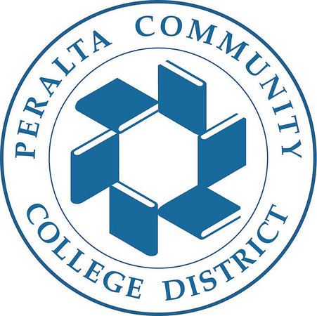
PERALTA COMMUNITY COLLEGE DISTRICT
DISTRICT ADMINISTRATIVE CENTER (DAC)
FACILITY RESERVATION FORM
Application for Use of Facilities

DAC Board Room DAC Atrium DAC Parking Lot
Date of Application:
333 East Eighth Street 333 East Eighth Street 333 East Eighth Street
Oakland, CA 94606 Oakland, CA 94606 Oakland, CA 94606

Name of Person Requesting Application :

Name of Organization:

Non Profit:

Street Address City Zip Code Email Address

Purpose for use:

Date and time requested are as follows:

Month: Date: Time facility Time facility
to be opened: to be closed

State nature of use, title of performance, names of speakers, as appropriate. Describe fully. Use reverse side if necessary.

Number of Attendees: Admission Fee: $ Tickets on Sales at:
Are contributions, collections, dues, registration fees or other donations to be received? Yes No

Amount per Attendee: $ Estimated Total: $

Requests to reserve the Board Room, Atrium, and/or Parking Lot after hours will be reviewed by Dr. Ikharo, Vice Chancellor, General Services, on a case-by-case basis.
The applicant shall be held responsible for any and all loss, accident, neglect, injury or damage to person, life or property which may be the result of, or may be caused by his or its use or occupancy of the herein described premises. The applicant agrees to protect, defend and indemnify the Peralta Community College District, its officers, employees and agents and save them harmless in every way from all suits or actions at law for damage or injury to persons, life or property that may arise or be occasioned in any way because of his or its use of said premises.
The applicant, if requested, agrees and will provide a policy of public liability and property damage insurance for the protection of the public and the lessor with limits of not less than $100,000 to public liability and $50,000 property damage.
The undersigned states that, to the best of his knowledge, the school property for the use of which application is hereby made will not be used for the commission of any act which is prohibited by law, or for the commission of any crime. I certify (or declare) under penalty of perjury that the foregoing is true and correct.
Signature of Applicant ________________________________ Date:_______________
DISTRICT USE ONLY
Facility and Service Costs: Costs to be charged to Applicant? Yes No
Facility Cost $________ Police Services Needed:
Custodian Needed: Yes No Public Liability and Property Damage Insurance Required? Yes No TOTAL $________ Costs Payment Deadline:

Approved:_______________________________________________________
Signature Date
Peralta Employee(s) on Site:________________________________________

